**Critical Thinking and Problem Solving Meeting 4**



**From:**

AL AZHAR RIZQI RIFA’I FIRDAUS

**Class:**

1 I

**Absence:**

01

**Major:**

Information Technology

**Study Program:**

Informatic Engineering

TASK 1

The robot beaver can mul9task. Each task requires 1, 2, 3, or more hours of work. In one hour, the robot can only do one task. At the end of each hour, he checks if there is a new task:

1. If yes, then the robot must start working on the new task.

2. If not, the robot con9nues to do the task that has not been done for the longest 9me.

The following is an example of a work schedule for the robot in a day.

At 8:00, there is a task that takes 7 hours

At 10:00, comes the task that takes 3 hours

At 12:00 o'clock, comes the task that takes 5 hours

In the table, the yellow color indicates the task is in progress, the white color indicates the task is pending.

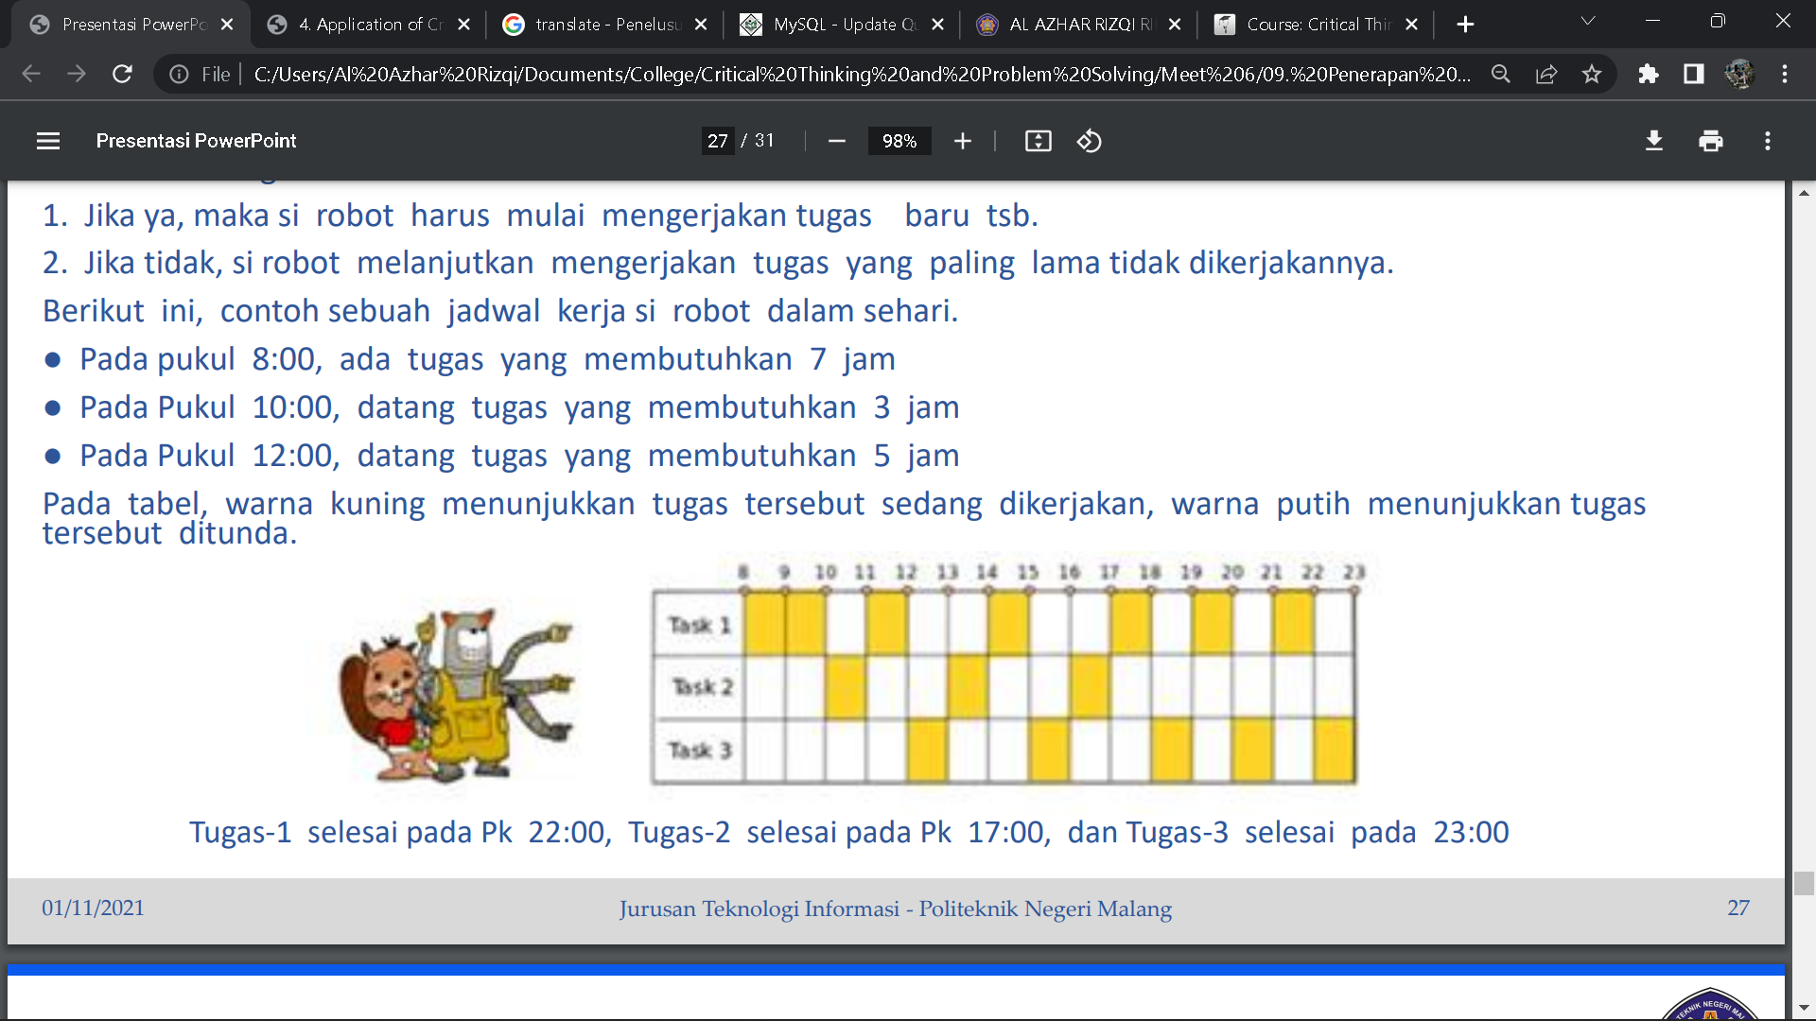

Task-1 finishes at 22:00, Task-2 finishes at 17:00, and Task-3 finishes at 23:0

If the robot accepts the following four tasks:

Task-1: at 8:00 p.m. takes 5 hours

Task-2: at 11:00 takes 3 hours

Task-3: at 14:00 takes 5 hours

Task-4: at 17:00 takes 2 hours

At what time will each task be completed. Robot can do only one task at once time.

Answer :

|  |  |  |  |  |  |  |  |  |  |  |  |  |  |  |  |  |
| --- | --- | --- | --- | --- | --- | --- | --- | --- | --- | --- | --- | --- | --- | --- | --- | --- |
|  | 8 | 9 | 10 | 11 | 12 | 13 | 14 | 15 | 16 | 17 | 18 | 19 | 20 | 21 | 22 | 23 |
| Task 1 | V | V | V |  | V |  |  |  | V |  |  |  |  |  |  |  |
| Task 2 |  |  |  | V |  | V |  | V |  |  |  |  |  |  |  |  |
| Task 3 |  |  |  |  |  |  | V |  |  |  | V |  | V | V | V |  |
| Task 4 |  |  |  |  |  |  |  |  |  | V |  | V |  |  |  |  |

Task 1 finishes at 16.00, task 2 finishes at 15.00, task 3 finishes at 22.00, task 4 finishes at 19.00

TASK 2

During their 6-day vacation, Laravel and Zend have a plan to go to Grandma's village. Incidentally, there were three farmers A, B, and C who needed help in cultivating their respective fields. They offered Laravel and Zend a fee if they would help them. Each of these farmers makes a different offer:

• Farmer A offers 10 thousand rupiah for each (Laravel and Zend) every day.

• Farmer B will only give Zend ten thousand rupiah on the first day then each subsequent increase by 10 thousand to 20 thousand, 30 thousand, and so on, while he will give Laravel on the first day 100 thousand rupiah and then decrease 10 thousand rupiah every following day to 90 thousand, 80 thousand, and so on.

• Farmer C is not interested in Zend's help, so he will only give 1 thousand rupiah on the first day and will not give anything on the next day. As for Laravel, he will give a thousand rupiah on the first day, then every next day double from the previous. So, Laravel will get a thousand rupiah, 2 thousand rupiah, 4 thousand rupiah, 8 thousand rupiah and so on. They intend to spend every day of their holiday in grandmother's village helping the farmer, and they both have promised to work for the same farmer. Regarding wages, they have also secretly agreed to share equally what they get.

For which farmers do they work so that they can get the most fee

Answer :

|  |  |  |  |  |  |  |  |  |  |
| --- | --- | --- | --- | --- | --- | --- | --- | --- | --- |
|  |  | 1 | 2 | 3 | 4 | 5 | 6 | Total | |
| Farmer A | Laravel | 10k | 10k | 10k | 10k | 10k | 10k | 60K | 120k |
| Zend | 10k | 10k | 10k | 10k | 10k | 10k | 60K |
| Farmer B | Laravel | 10k | 20k | 30k | 40k | 50k | 60k | 210k | 660k |
| Zend | 100k | 90k | 80k | 70k | 60k | 50k | 450k |
| Farmer C | Laravel | 1k | 2k | 4k | 8k | 16k | 32k | 63k | 64k |
| Zend | 1k |  |  |  |  |  | 1k |

They have to work for farmer B in order to get the most wages.

TASK 3

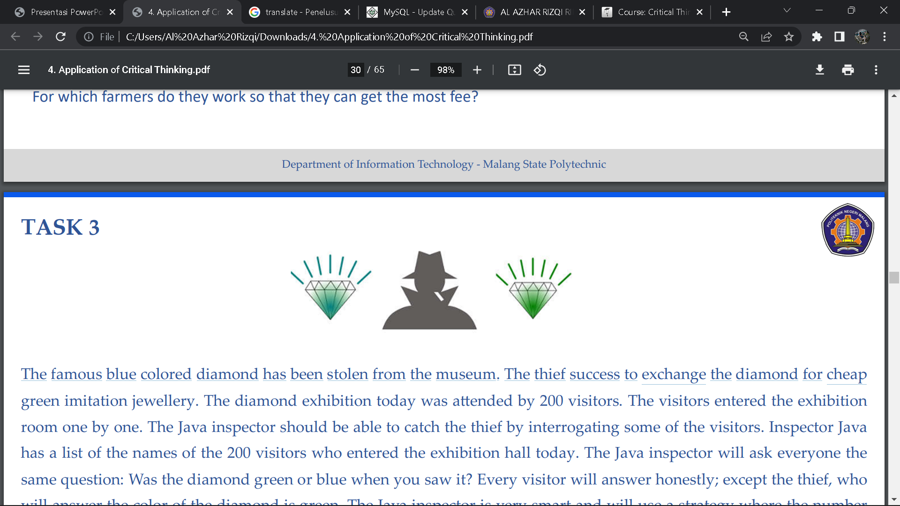

The famous blue colored diamond has been stolen from the museum. The thief success to exchange the diamond for cheap green imitation jewellery. The diamond exhibition today was a9ended by 200 visitors. The visitors entered the exhibition room one by one. The Java inspector should be able to catch the thief by interrogating some of the visitors. Inspector Java has a list of the names of the 200 visitors who entered the exhibition hall today. The Java inspector will ask everyone the same question: Was the diamond green or blue when you saw it? Every visitor will answer honestly; except the thief, who will answer the color of the diamond is green. The Java inspector is very smart and will use a strategy where the number of people to be asked question will be minimal. Which of the following statements can the Java Inspector deliver without lying? Explain

a) This task is a difficult one; I need to ask at least 200 people, but the most likely is 199 people.

b) I can't promise anything. If I am unlucky, then I will question every visitor.

c) It's not enough to just ask 10 people (unless I'm lucky) but I believe I can get my job done by asking less than 200 people.

d) I can guarantee that I can find the thief by simply asking less than 10 people

Answer :

In my opinion the answer is B because reasonable choices. If A there is a statement that this task is a difficult task even though it could be an easy task. if B contains a statement asking every visitor even though only 199 is enough. and if D is very unlikely by asking less than 10 people because it uses brute force method